Author & Author

Title Title Title (English)

Abstract (max. 150 words)
Texttexttext.

Keywords (max. 5)
Keyword 1; Keyword 2; Keyword 3; Keyword 4; Keyword 5

Please note: To make journal | adventure therapy more visible, each article also requires an English title, an English abstract and English keywords. The authors are responsible for the correctness of these elements (linguistically and grammatically). There is no quality check by the editors!

Heading
Texttexttext.
Texttexttext.
Texttexttext.

Heading
Texttexttext.

2.1 Subheading
Texttexttext.
Texttexttext.

2.2 Subheading

2.2.1 Subheading
Texttexttext.
Texttexttext.

Subheading

Lists and citations
- Enumeration (enumerate either with numbers, or…
- Enumeration
- Enumeration
- Bullet point 1 (…with bullets)
- Bullet point 2
- Bullet point 3
Long quote: Please format citations in the text over 3 lines long. Long quotation Long quotation Long quotation Long quotation Long quotation Long quotation Long quotation Long quotation Long quotation Long quotation Long quotation Long quotation Long quotation (from three lines).

Sources in the text
A single Author: (Author 2020) or Author (2020). Two Authors: (Author X and author Y 2020) or Author X and Author Y (2020). Several Authors: (Author X, Author Y and Author Z 2020) or Author X, Author Y and Author Z (2020). More than six Authors: (Author X, Author Y, Author Z, Author XX, Author XY, Author XZ et al 2020) or Author X et al. (2020).
In the case of multiple references to more than two Authors: from the second mention: (Author X et al. 2020) or Author X et al. (2020).

Tables und figures
This first paragraph has nothing to do with tables and figures. It is only intended to show how a first paragraph and the subsequent paragraphs differ from each other. First paragraph First paragraph First paragraph First paragraph First paragraph First paragraph First paragraph First paragraph First paragraph First paragraph First paragraph First paragraph First paragraph First paragraph First paragraph First paragraph First paragraph.
This is the next paragraph, which is probably used most often in the article. Paragraph before table/figure Paragraph before table/figure Paragraph before table/figure Paragraph before table/figure Paragraph before table/figure Paragraph before table/figure Paragraph before table/figure Paragraph before table/figure Paragraph before table/figure Paragraph before table/figure Paragraph before table/figure Paragraph before table/figure.
Table 1: Table labeling above table (example)
 | [Characteristic value 1] | [Characteristic value 2] | [Characteristic value 3] | [Characteristic value 4] | [Characteristic value 5]
Measurement time 1 | 4,25 | 4 | 22 | 0,55
Measurement time 2 | 4,34 | 4 | 22 | 0,49 | 0,63
Notes Text Text Text Text Text Text Text Text Text Text Text Text Text Text Text Text Text Text Text

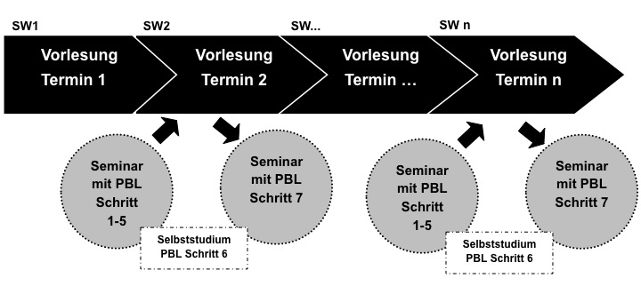
Figure 1: Illustration caption under illustration [Please show images with maximum contrast]

Text after to table/illustration Text after to table/illustration Text after to table/illustration Text after to table/illustration Text after to table/illustration Text after to table/illustration Text after to table/illustration Text after to table/illustration Text after to table/illustration Text after to table/illustration Text after to table/illustration Text after to table/illustration Text after to table/illustration Text after to table/illustration Text after to table/illustration Text after to table/illustration Text after to table/illustration Text after to table/illustration.
Further text Further text Further text Further text Further text Further text Further text Further text Further text Further text Further text Further text Further text Further text Further text Further text Further text Further text Further text Further text Further text Further text Further text Further text Further text.

Pictures
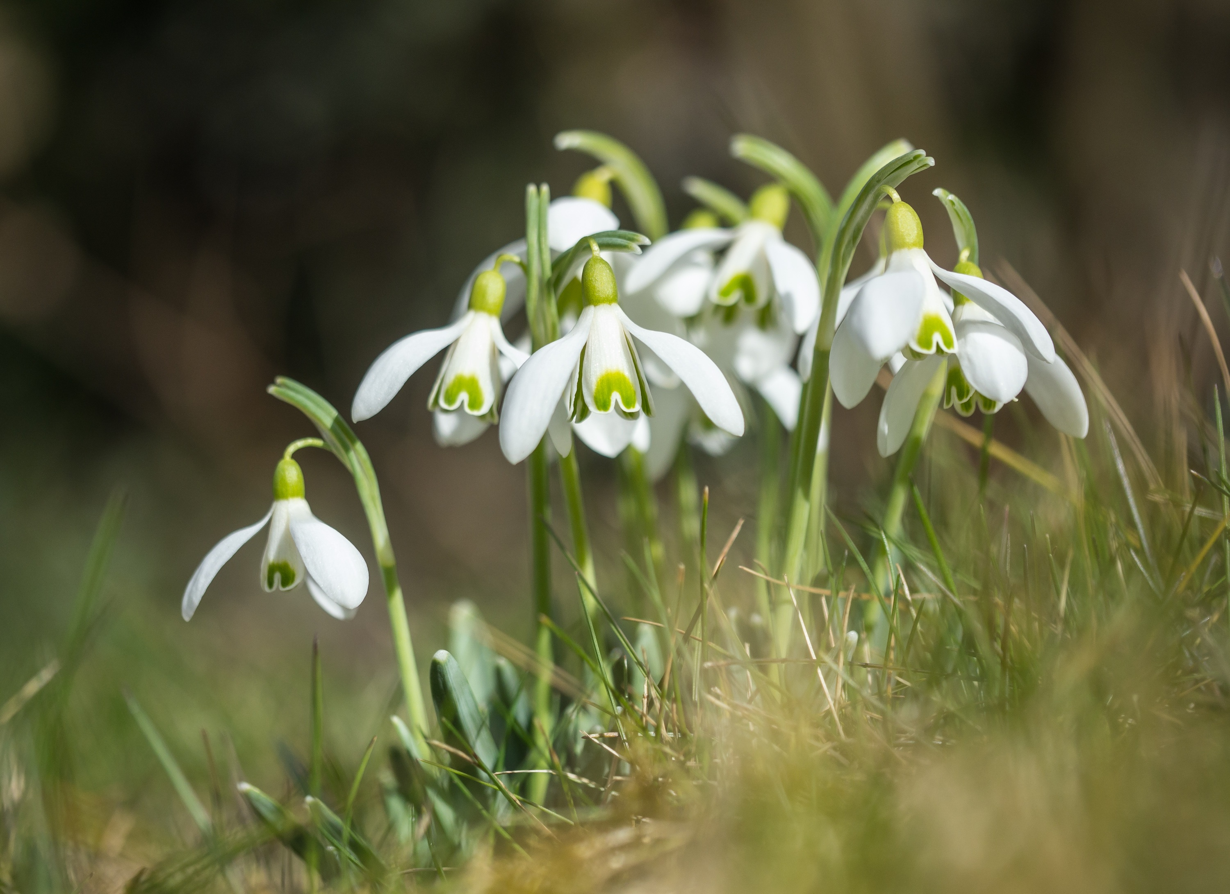
Figure 2: Illustration caption under illustration [images also in color]

[NOTICE ON PICTURE AND PERSONALITY RIGHTS] Please be sure to observe the copyrights for pictures and ask the people pictured for permission. The authors themselves are liable in this regard!
Further Text Further Text Further Text Further Text Further Text Further Text Further Text Further Text Further Text Further Text Further Text Further Text Further Text Further Text Further Text

Remarks
[Acknowledgments and / or special references to other supporters of their work can be named here. Please also indicate here if your (scientific) work was carried out as part of a specific funding (e.g. in a funding line of a ministry), or was otherwise supported by external funds (e.g. by private funding).]

Literature (examples of references)
[BOOK/EDITORI]
American Psychological Association (Ed.). (2020). Publication manual of the American Psychological Association (7th ed). Washington, DC: American Psychological Association.
Biggs, J. & Tang, C. (2007). Teaching for Quality Learning at University. New York: McGraw Hill.
[CONTRIBUTION IN EDITORIAL]
Eugster, B. (2012). Leistungsnachweise und ihr Ort in der Studiengangsentwicklung. Überlegungen zu einer Kritik des curricularen Alignments. In T. Brinker & P. Tremp (Hrsg.), Einführung in die Studiengangsentwicklung (45-62). Bielefeld: wbv.
[MAGAZINE CONTRIBUTION]
Ho, A. (2000). A conceptual change approach to staff development. International Journal for Academic Development, 5 (1), 30-41.
[LECTURE/PRESENTATION]
Euler, D. (2012). Hochschulentwicklung – eine (neue) Herausforderung für die Wirtschaftspädagogik? Keynote auf der Sektionstagung Berufs- und Wirtschaftspädagogik der DGfE, 25. September 2012.
[ONLINE-SOURCE]
Bundesministerium für Bildung und Forschung (2014). Verbindliche Regelungen zur Erstellung von Fortsetzungsanträgen im Bund-Länder-Programm für bessere Studienbedingungen und mehr Qualität in der Lehre. Online unter: http://www.qualitaetspakt-lehre.de/_media/Foerderaufruf_Periode_2.pdf [12.12.2016]

Authors
[PLEASE INSERT ALSO A PICTURE]
Title, First name, Last name. Institution (University or similar), Location, Country; Email: author@university.com
Title, First name, Last name. Institution (University or similar), Location, Country; Email: author@university.com

Suggested citation: Last name, abbreviation First name & Last name, abbreviation First name (year). Titletitletitle. journal | adventure therapy, Year 3/2022, online under: www.journal-adventure-therapy.com

EDITORS: Alexander Rose (Spain), Christiane Thiesen (Germany), Per Wijnands (Niederlande)
E-Mail: editors@adventure-therapy-edition.com
Adventure Therapy Institute (ATI)
Institute for Adventure, Outdoor & Nature GmbH & Co. KG | Hofstattgasse 1 | D-88131 Lindau | Germany
HRA 11089 | Amtsgericht Kempten
Ust. ID Nr./ VAT: DE350253116

PUBLISHER’S NOTE: The publisher has tried to identify all copyright holders of quotations, texts, images, figures and illustrations.
Unfortunately, this was not always possible. If we forgot someone, we kindly ask the copyright holders to contact us.
The authors are responsible for the form and contents of this publication.

PUBLISHER: ZIEL – Center for interdisciplinary experience-based learning GmbH | Zeuggasse 7 – 9 | 86150 Augsburg | Germany
E-Mail: adventure-therapy@ziel.org, Tel. +49 (0) 821/42099-77, Fax +49 (0) 821/42099-78

Amtsgericht Augsburg HRB 16859 | Sitz der Gesellschaft ist Augsburg | Geschäftsführer: Alex Ferstl, Michael Rehm | USt-IdNr. DE 199299854

© All rights reserved. No part of this book must be reproduced (print, photocopy or other techniques) or processed,
copied or distributed with electronic systems without written permission of the publisher.

HERAUSGEBER*INNEN: Alexander Rose (Spain), Christiane Thiesen (Germany), Per Wijnands (Niederlande)
E-Mail: editors@adventure-therapy-edition.com
Adventure Therapy Institute (ATI)
Institute for Adventure, Outdoor & Nature GmbH & Co. KG | Hofstattgasse 1 | D-88131 Lindau | Germany
HRA 11089 | Amtsgericht Kempten
Ust. ID Nr./ VAT: DE350253116

Wichtiger Hinweis des Verlags: Der Verlag hat sich bemüht, die Copyright-Inhaber aller verwendeten Zitate, Texte, Bilder, Abbildungen und Illustrationen zu ermitteln. Leider gelang dies nicht in allen Fällen. Sollten wir jemanden übergangen haben, so bitten wir die Copyright-Inhaber, sich mit uns in Verbindung zu setzen. Inhalt und Form der vorliegenden Publikation liegen in der Verantwortung des Autors.

Verlag: ZIEL – Zentrum für interdisziplinäres erfahrungsorientiertes Lernen GmbH | Zeuggasse 7 – 9 | D-86150 Augsburg | Deutschland
E-Mail: adventure-therapy@ziel.org, Tel. +49 (0) 821/42099-77, Fax +49 (0) 821/42099-78

Amtsgericht Augsburg HRB 16859 | Sitz der Gesellschaft: Augsburg | Geschäftsführer: Alex Ferstl, Michael Rehm | USt-IdNr. DE 199299854

© Alle Rechte vorbehalten. Kein Teil dieses Buches darf in irgendeiner Form (Druck, Fotokopie oder einem anderen Verfahren)
ohne schriftliche Genehmigung des Verlags reproduziert oder unter Verwendung elektronischer Systeme verarbeitet, vervielfältigt oder verbreitet werden.

ISSN 2700-7375

This is footnote ...

